**PROJECT REPORT**

|  |  |
| --- | --- |
| **TEAM ID** | **PNT2022TMID51381** |
| **PROJECT TITLE** | **ANALYTICS OF HOSPITAL HEALTH**  **CARE DATA** |

**TEAM MEMBERS:**

JIBIN S S(Team Leader)

EDWIN RAJ C(Team Member 1)

LIJU K(Team Member 2)

KUMAR K(Team Member 3)

# CHAPTER 1

## INTRODUCTION

This project is about the anlytics for hospital health care data using data analytics. Data Analytics is the process of examining data sets in order to find trends and draw conclusions about the information they contain. The data anlytics is done with the specilized systems and soft ware. Data anlytics technologies and techniques are widely used in commercial industriesto enable organizations to make more informational businees disisions.

## 1.1 PROJECT OVERVIEW

Recent Covid-19 pandamic has raised alarms over one of the most overlooked areas to focus

Example: Health care Management

While health care management has various use cases for using datascience,patient length of stay in one critical parameter to observe and predict if one wants to improve the efficiencyof health care management in a hospital.

This parameter helps hospitals to identify patients of high LOS risk (patients who stay longer) at the time of admission. once identified patients with high LOS risk can have their treatment plan optimized to minimizeLOS and lower the chance of staff/visitors infection.

Also prior knowledge of Los can aid in logistics such as room and bed allocation planning.

Suppose you have been hired as Data Scientist of Health Man -not for profit organization dedicated to manage the functioning of hospitals in a professional and optimal manner.

## 1.2 PURPOSE

Data anlytics in health care is vital. It healps healyh care organizations to evaluate and develop practitioners, detect anomalies in scans and predict out breaks in illness, per the Harvard Businees School. Data Analytics can also lower costs for health care organizations and boost business intelligence . Hospital data anlytics can look over patient data and any prescribed medication to alert doctors and patients of incorrect dossages or wrong prescriptions, which lessens human error and the cost to your hosptital. This in turn helps in ganing better insights znd also enables healthcare practitioners to make well-informed decisions

# CHAPTER 2

## LITERATURE SURVEY

The main aim of this paper is to provide a deep anlytics on the research feild of healthcare data anlytics, This is analyzing the previous studies and works in this research area ,as well as highlighting some of the guidelines and gaps. This study has used seven popular databases and selected most relevent papers ,in order to conduct this paper . The paper has listed some of thedata anlytics tools and techniques that have been used to improve healthcare performance in many areas such as medical operators ,decision making reports ,predction and prevention system. Moreover, the systematic review has showed an interesting demo graphic of fields of publication ,research approaches,as well as outlined some of the possible reasons and issues associate with health care data anlytics ,based on geographical distribution theme[1].

This paper deals with advanced analytical methods to focus on healthcare. This includes the clinical prediction models ,temporal data mining methods,and visual anlytics . Integrating hetrogeneous data such as clinical and geonomic data is essential for improving retrivel techniques that can enhance the quality of biomedical search will be presented . Data publishing techniques that can enhance the quality of biomedical search will be presented. Data privacy is an extreamely important concern in healthcare . Privacypreserving data techniques will therefore be presented [2].

One of the promises of growing critical mass of clinical data

accumulating in electronic health reccord(EHR) system is secondary use or it may be reuse of data for other purpose ,such as quality improvement and clinical research .(1)The growthofsuch data has increased dramatically in recent years due to incentives for EHRadoption in the US funded by the Health Information Technology for EconomicandClinical Health (HITECH) Act (2). In the meantime, there has also seen substantial growth in other kinds of health-related data, most notably through effortstosequence genomes and other biological structures and functions(3). The analysisofthis data is usually called analytics (or data analytics). This chapter will definetheterminology of this field, provide an overview of its promise, describe what workhas been accomplished, and list the challenges and opportunities going forward[3].

Clinicians, healthcare providers-suppliers, policy makers and patientsareexperiencing exciting opportunities in light of new information deriving fromtheanalysis of big data sets, a capability that has emerged in the last decades. Duetothe rapid increase of publications in the healthcare industry, we have conductedastructured review regarding healthcare big data analytics. With referencetotheresource-based view theory we focus on how big data resources are utilizedtocreate organization values/capabilities, and through content analysis of the selectedpublications we discuss: the classification of big data types related to healthcare, the associate analysis techniques, the created value for stakeholders, the platformsand tools for handling big health data and future aspects in the field. We present anumber of pragmatic examples to show how the advances in healthcare weremadepossible. We believe that the findings of this review are stimulating

andprovidevaluable information to practitioners, policy makers and researchers whilepresenting them with certain paths for future research[4].

In this modern techno-world, the term data is unavoidable and certainly, nothing is possible without its usage. The trends about how to analyze the dataarethe need of the hour. Data analytics is becoming a future escalating tool of all industries including medicine, robotics, etc. This article briefly explains howdataanalytics is used in healthcare systems. Health care is the process of maintainingand improving the health of an individual by preventing, diagnosing andtreatingthe diseases, illness and other physical and mental imbalances in people. Dataanalytics is classified into four types and they are descriptive, diagnostic, predictiveand prescriptive analysis. Health care makes use of prescriptive analysis toarriveatthe best results and make better decisions. Big data plays a major roleindataanalytics. It helps the data analysts to collect data from the patients and storethemefficiently. After the completion of this whole article, the reader will be abletogetthe collective idea about health care analytics.[5]

## 2.1 EXISTING SYSTEM

♢ The already existing model is trained with minimal parameters

♢ Low accuracy in prediction

♢ No feature extraction done

♢ High complexity

## 2.2 REFERENCES

[1]. Mohammad Alkhatib , Amir Talaei-Khoei (University of Nevada,Reno)Amir Talaei-Khoei

University of Nevada, Reno | UNR · Department of AccountingandInformation Systems PhD of Information Systems-Amir Ghapanchi

[2]. From:”Book of Data Analytics” Chandank Reddy(Wayne State University) CharuC.Aggarwal(Watson Research Center)

[3]. From: Hoyt,RE,Yoshihashi,A,Eds.(2014).Health Informatics:Practical GuideforHealthcare and formation Technology Professionals,SixthEdition.Pensacola,FL,Lulu.com.

[4]. Panagiota Galetsia , Korina Katsaliakia , Sameer Kumarb,⁎ a School ofEconomics, Business

Administration & Legal Studies, International HellenicUniversity, 14th km Thessaloniki-N.

Moudania, Thessaloniki, 57001, GreecebOpusCollege of Business, University of St. Thomas Minneapolis Campus, 1000LaSalleAvenue, Schulze Hall 435, Minneapolis, MN 55403, USA

[5]. from”n book: Innovative Data Communication Technologies and Application(pp.83-96)” P. Nagaraj-Professor (Assistant) at Kalasalingam University

[6]. Yang J.-J., Li J., Mulder J., Wang Y., Chen S., Wu H., Wang Q., PanH. Emerginginformation technologies for enhanced healthcare.Comput.ind.2015;69:3-

11.doi:10.1016/j.compimd.2015.01.012. [CrossRef] [Google Scholar]

[7]. Cortada J.W., Gordon D., Lenihan B. The Value of Analytics in Healthcare. IBMInstitute for

Business Value; Armonk, NY, USA: 2012. Report No.: GBE03476- UUSEN- 00. [Google Scholar].

[8]. Makary M.A., Daniel M. Medical error-the third leading cause of deathintheUS.Br. Med. J.

2016;353:i2139. doi: 10.1136/bmj.i2139. [PubMed] [CrossRef] [GoogleScholar].

[9]. Prokosch H.-U., Ganslandt T. Perspectives for medical informatics. MethodsInf. Med.

2009;48:38–44. doi: 10.3414/ME9132. [PubMed] [CrossRef] [Google Scholar].

[10]. Simpao A.F., Ahumada L.M., Gálvez J.A., Rehman M.A. A reviewof analyticsandclinical informatics in health care. J. Med. Syst. 2014;38:45. doi: 10.1007/s10916-014-0045-x. [PubMed]

[CrossRef] [Google Scholar].

[11]. Ghassemi M., Celi L.A., Stone D.J. State of the art review: The data revolutionincritical care. Crit. Care. 2015;19:118. doi: 10.1186/s13054-015-0801-4. [PMCfreearticle] [PubMed] [CrossRef]

[Google Scholar].

[12]. Tomar D., Agarwal S. A survey on Data Mining approaches for Healthcare. Int. J. Bio-Sci.

Bio-Technol. 2013;5:241–266. doi: 10.14257/ijbsbt.2013.5.5.25. [CrossRef][Google Scholar]

[13]. K. Jee and G. H. Kim, “Potentiality of big data in the medical sector: Focusonhow to reshape the healthcare system,” Healthc. Inform. Res., vol. 19, no. 2, pp. 79–85, Jun. 2013. doi:

10.4258/hir.2013.19.2.79.

[14]. J. King, V. Patel, and M. F. Furukawa, “Physician adoption of electronic healthrecord technology to meet meaningful use objectives: 2009–2012,” The Officeof theNational Coordinator for Health Information Technology, Tech. Rep., Dec. 2012.

[15]. V. Mayer-Schönberger and K. Cukier, Big Data: A Revolution That Will Transform How We Live, Work, and Think. Eamon Dolan, 2014.

[16]. J. Rapoport, D. Teres, Y. Zhao, S. Lemeshow Length of stay data as a guidetohospital economic performance for icu patients Med Care, 41 (3) (2003), pp. 386- 397

## 2.3 PROBLEM STATEMENT AND DEFINITION

♢The aim is to accurately predict the Length of Stay for each patient oncasebycase basis so that the Hospitals can use this information for optimal resourceallocation and better functioning.

♢ The length of stay is divided into 11 different classes ranging from0-10daysto more than 100 days

# CHAPTER 3

**IDEATION & PROPOSED SOLUTION**

## 3.1 EMPATHY MAP CANVAS

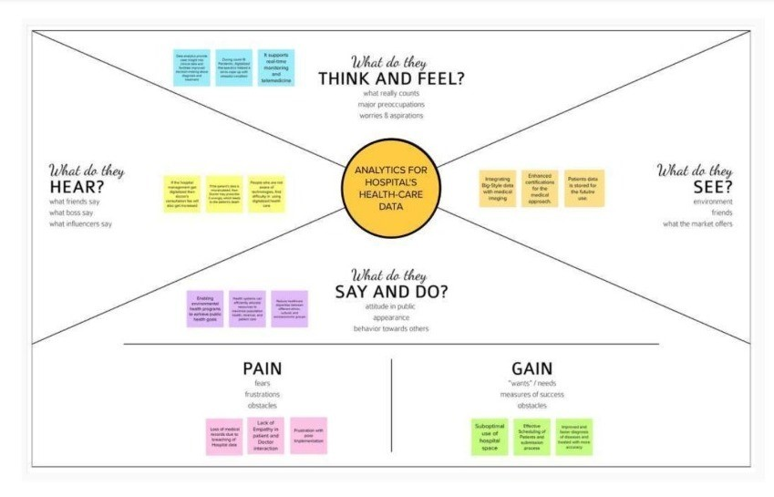

## 3.2 IDEATION & BRAINSTORMING

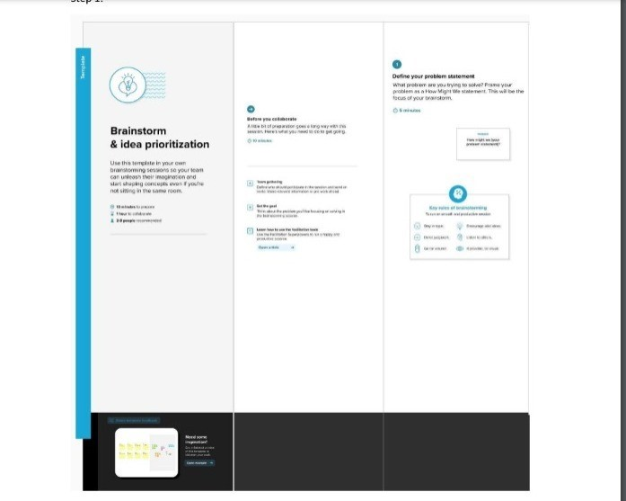

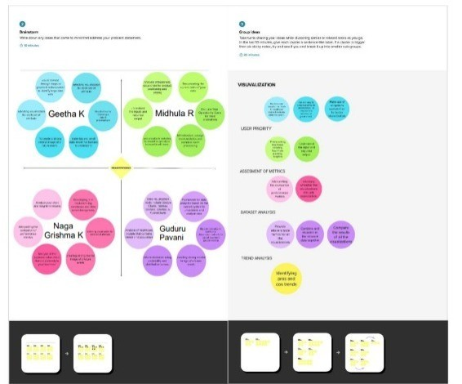

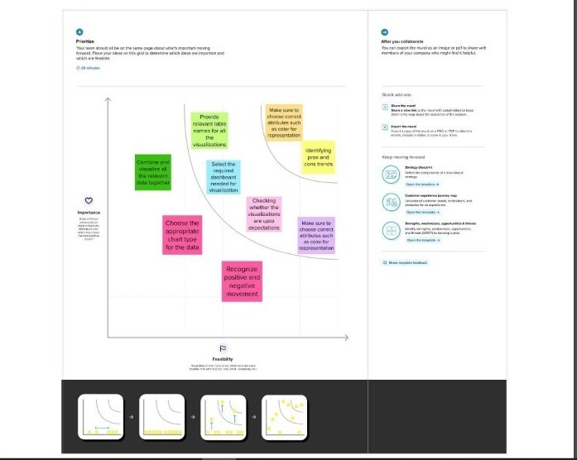

## 3.3 PROPOSED SOLUTION

Predicting the length of stay of patients.

The length of the stay can be predicted using either Randomforest orDecision Tree for more accuracy. Certain parameters like age, stageof thediseases, disease diagnosis, severity of illness, type of admission, facilitiesallocated, etc., are used for prediction. IBM Cognos will be used for data analytics.

The model will be trained using colab.It predicts the length of stay (LOS) of the patients with more accuracy. As a result proper resources and therapy canbeprovided.Patients can get proper treatment and better medical care thanbeforewhich helps them for their faster recovery. So the prediction minimizestheoverflow of patients and helps in resource management and optimizetheirresource utilization. Hence this leads to faster recovery and lower the expensesfortreatment. It improves the trust in hospital management**.**

It avoids the major risk of spreading infection among the hospital staff. Thisleads to overall safety of hospital staff and patients. Resource consumptionisoptimized. This model can be used by all government hospitals, private hospitals, and this model is also trained with the real world hospital survey for betterprediction small clinics. Length of the stay will be predicted with more accuracy. This model predictsthe length of the stay for all kinds of patients and predicts with more accuracy

## 3.4 PROBLEM SOLUTION

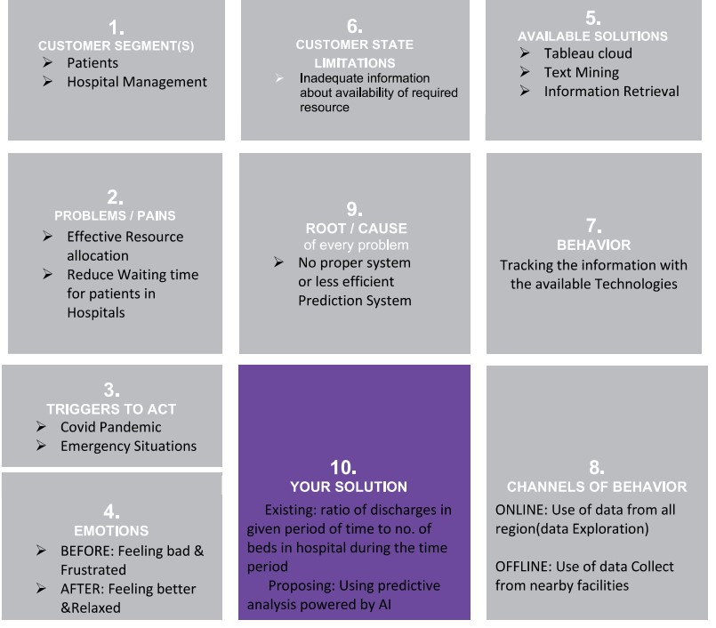

# CHAPTER 4

**REQUIREMENT ANALYSIS**

## 4.1 FUNCTIONAL REQUIREMENT

|  |  |  |
| --- | --- | --- |
| FR No. | Functional Requirement (Epic) | Sub Requirement (Story /  Sub-Task) |
| FR-1 | Collect data | Data from various sources are collected using different methods in order to provide optimized results. |
| FR-2 | Data Cleaning and Wrangling | When combining multiple data sources, there are many opportunities for data to be duplicated or mislabeled hence we cleanse the data |
| FR-3 | Creating data model | The process of analyzing and defining all the data, as well as the relationships between those bits of data comes under this. |
| FR-4 | Prediction and Analysis | The hidden trends are analyzed and the final results are predicted using machine learning and AI algorithms. |

## 4.2 NON FUNCTIONAL REQUIREMENT

|  |  |  |
| --- | --- | --- |
| FR No | Non-Functional Requirement | Description |
| NFR-1 | Usability | The project must be easy to use. The user needs to have a good experience while working with the interface. |
| NFR-2 | Security | Every user can access the website only if they posses the password. The database is secured with encryption techniques which provides high levels of security |
| NFR-3 | Reliability | The project must have minimal degree of failure under normal usage and how often does the user get access to this work |
| NFR-4 | Performance | The project must respond quickly to the user's actions or even if the user has to wait the waiting period must be short. |
| NFR-5 | Availability | The project is platform independent. It runs perfectly on almost every platform |
| NFR-6 | Scalability | The project allows multiple users to handle the data at the same time. It is highly scalable since adding features and making advancements in the website is uncomplicated. |

# CHAPTER 5

## PROJECT DESIGN

### 5.1 DATA FLOW DIAGRAMS

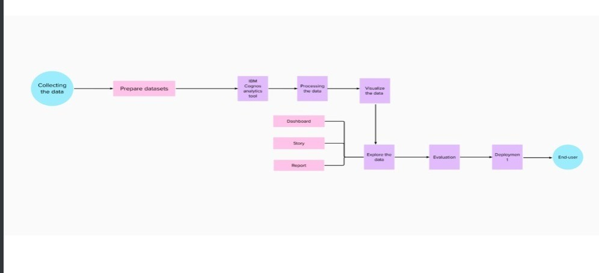

## 5.2 SOLUTION & TECHNICAL ARCHITECTURE

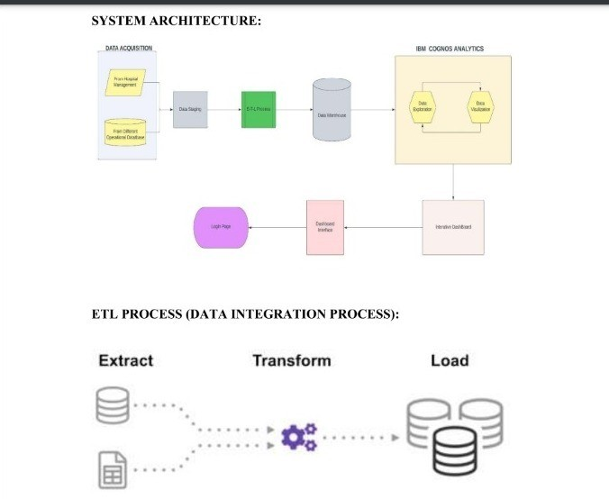

## 5.3 USER STORIES

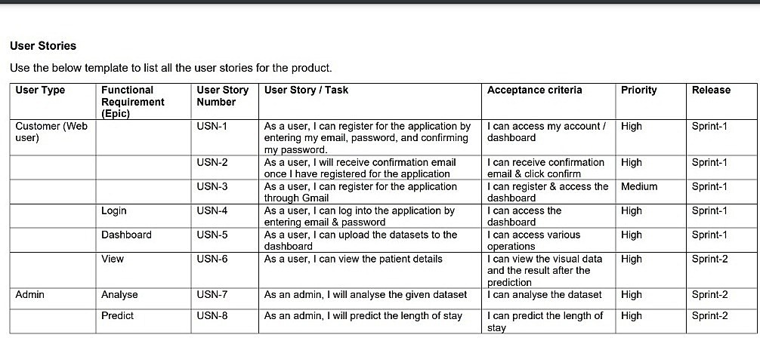

# CHAPTER 6

**PROJECT PLANNING & SCHEDULING**

## 6.1 SPRINT PLANNING & ESTIMATION

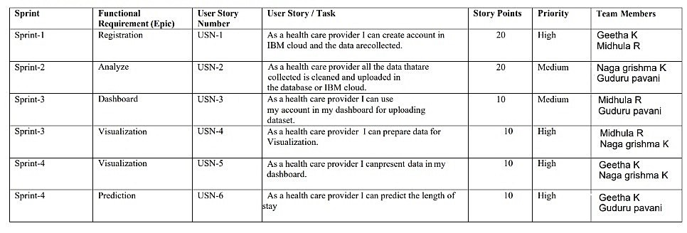

## 6.2 SPRINT DELIVERY SCHEDULE

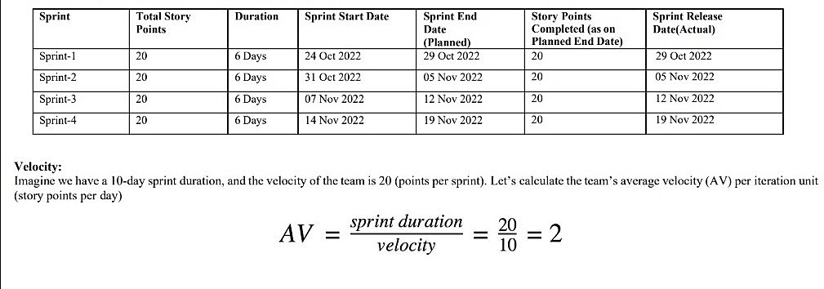

**6.3 REPORTS FROM JIRA**

## Burnup chart

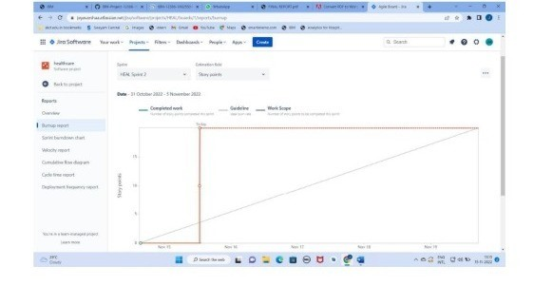

### Burn down chart

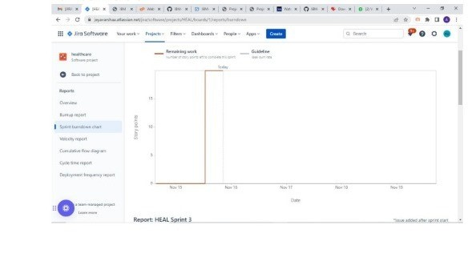

**CODING & SOLUTIONING**

### 7.1 FEATURE 1

* Fetched the data from DB2 database.
* Creating responsive dashboard.
* Inserting filter for each chart
* Creating report
* Created reports using multiple graphs and charts

### 7.2 FEATURE 2

* Creating stories and performed.
* Perform animation render image from website.
* Included graphs and charts.
* Creating web application using bootstrap.
* Embedded the cognos with web application.

### 7.3 Database Schema

* case_id
* Hospital_code
* Hospital_type_code
* City_Code_Hospital
* Hospital_region_code
* Available Extra Rooms in Hospital
* Department
* Ward_Type
* Ward_Facility_Code
* Bed Grade
* Patient id
* City_Code_Patient ● Type of Admission
* Severity of Illness
* Visitors with Patient
* Age
* Admission_Deposit
* Stay

## TESTING 8.1 Test Cases

♢ Verify user is able to see Home page.

♢ Verify user is able to see Dashboard page.

♢ Verify user is able to navigate to Report page.

♢ Verify user is able to navigate to story page.

♢ Verify filters are working

## 8.2 User Acceptance Testing

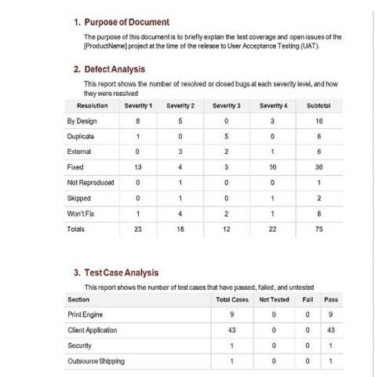

# RESULTS

## 9.1 PERFORMANCE METRICS

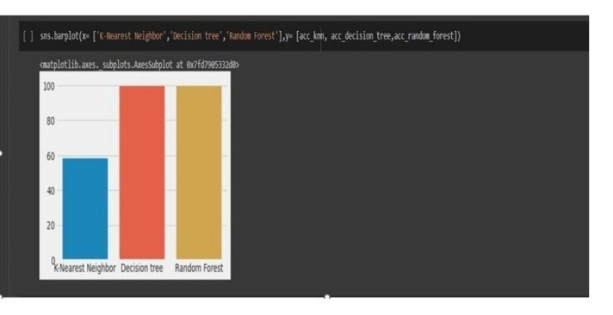

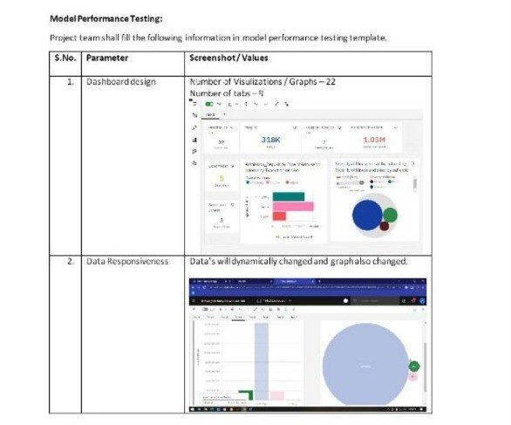

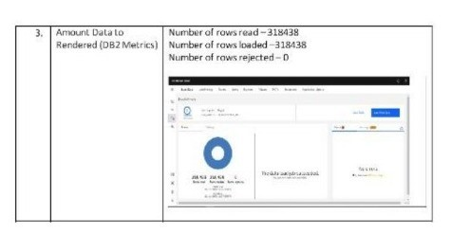

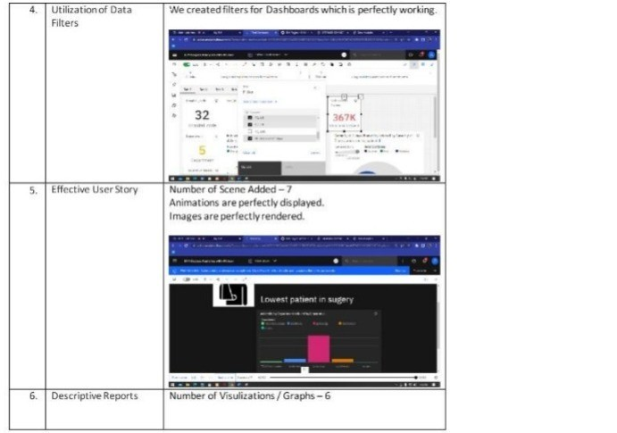

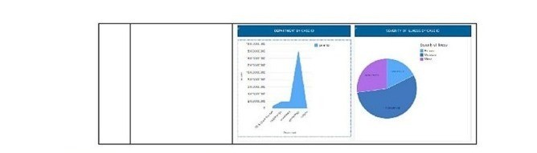

# CHAPTER 10

## ADVANTAGES AND DISADVANTAGES

### ADVANTAGES

♢ Cost-effective use of technology

♢ Improved project management

♢ Sustaining the improvements in the result

♢ Boosting hospital capacity

♢ Enhance the quality and efficiency of healthcare

♢ benefit areas like emergency preparation, charting, administration, compliance, and financial management.

♢ Analysing clinical data to improve medical research

♢ Using patient data to improve health outcomes

♢ Gaining operational insights from healthcare provider data

♢ Improved staffing through health business management analytics

♢ Early detection of disease.

♢ Prevention of unnecessary doctor's visits.

♢ Discovery of new drugs.

♢ More accurate calculation of health insurance rates.

♢ More effective sharing of patient data

### DISADVANTAGES

♢ Privacy

♢ Replacing Doctors

♢ Frustration with poor implementation.

♢ Cybersecurity risks

♢ Healthcare Regulatory Changes.

♢ Healthcare Staffing Shortages

# CHAPTER 11 CONCLUSION

The impact of data analytics in healthcare has already made a substantial difference in the ability of healthcare providers to offer patients high-quality careinan efficient, cost-effective manner.

However, the role of data analytics in improvingpatient outcomes and healthcare processes continues to grow and expandas moretypes of data become available and new tools are developed that make the resultsof the analytics clear and easy for healthcare professionals to access.

Realizing the potential of data analytics to transform the healthcare industrybegins by understanding how the technology can be applied to address healthcareproviders’ challenges, including staff recruitment and utilization, operational efficiencies, and enhanced patient experiences. Patient-centered healthcaredepends on knowing what patients want and need. Data analytics holds thekeytounlocking this vital information.

# CHAPTER 12 FUTURE SCOPE

Artificial Intelligence (AI) will play a significant role in data analyticsinhealthcare for the next decade. For example, the field of AI-enabled clinical decisionsupport is just emerging.

This type of support can compare patients who fit similarprofiles within a system, then it can alert doctors to trends in data that mayhavebeen overlooked. The use of big data in healthcare will include testingfor druginteractions that small studies are unlikely to catch and prevent patients fromtaking harmful drug combinations.

Decisions made by physicians, like what test or treatments to giveaparticular patient, makeup 80-90% of all healthcare spending, so usingartificial intelligence to make more educated decisions will bring down healthcare costs. It’scrucial to have informed leaders at the vanguard of these innovations in healthcare.

# CHAPTER 13 APPENDIX

**SOURCE CODE**

## HOME PAGE

|  |  |
| --- | --- |
| <!DOCTYPE html> | <html lang="en"> |
|  | <head> |
|  | <title>Data Analytics</title> |
|  | <meta charset="utf-8"> |
|  | <meta name="viewport" content="width=device-width, initial-scale=1"> |
|  | <link rel="stylesheet"  href="https://maxcdn.bootstrapcdn.com/bootstrap/3.4.1/css/bootstrap.min.css"> |
|  | <script src="https://ajax.googleapis.com/ajax/libs/jquery/3.6.0/jquery.min.js">< |
|  | <script src="https://maxcdn.bootstrapcdn.com/bootstrap/3.4.1/js/bootstrap.min.js |
|  | </head> |
|  | <body> |
|  |  |
|  | <nav class="navbar navbar-inverse"> |
|  | <div class="container-fluid"> |
|  | <div class="navbar-header"> |
|  | <a class="navbar-brand" href="#">Analytics for Hospitals' Health-Care Data</ |
|  | </div> |
|  | <ul class="nav navbar-nav"> |
|  | <li class="active"><a href="#">Home</a></li> |
|  | <li><a href="dashboard.html">Dashboard</a></li> |
|  | <li><a href="report.html">Report</a></li> |
|  | <li><a href="story.html">Story</a></li> |
|  | </ul> |
|  | </div> |
|  | </nav> |
|  |  |
|  | <div class="jumbotron"> |
|  | <center> <h4><i><b>Team ID : PNT2022TMID28558</b></i></h4></center> |
|  |  |
|  | </div> |
|  | <table class="table table-bordered"> |
|  |  |
|  | <tbody> |
|  | <tr> |

<td>Team Leader</td>

<td>GEETHA K</td>

</tr>

<tr>

<td>Team member</td>

<td>MIDHULA R</td>

|  |  |
| --- | --- |
|  | </tr>  <tr> |
|  | <td>Team member</td> |
|  | <td>NAGA GRISHMA K</td> |
|  |  |
|  | </tr> |
|  | <tr> |
|  | <td>Team member</td> |
|  | <td> GUDURU PAVANI</td> |
|  |  |
|  | </tr> |
|  | </tbody> |
|  | </table> |
|  | </body> |
|  | </htm        **DASHBOARD** |
| <!DOCTYPE html> |  |
|  | <!DOCTYPE html> |
|  | <html lang="en"> |
|  | <head> |
|  | <title>Data Analytics</title> |
|  | <meta charset="utf-8"> |
|  | <meta name="viewport" content="width=device-width, initial-scale=1"> |
|  | <link rel="stylesheet" href="https://maxcdn.bootstrapcdn.com/bootstrap/3.4.1/css |
|  | <script src="https://ajax.googleapis.com/ajax/libs/jquery/3.6.0/jquery.min.js">< |
|  | <script src="https://maxcdn.bootstrapcdn.com/bootstrap/3.4.1/js/bootstrap.min.js |
|  | </head> |
|  | <body> |
|  |  |
|  | <nav class="navbar navbar-inverse "> |

<div class="container-fluid">

<div class="navbar-header">

<a class="navbar-brand" href="#">Analytics for Hospitals' Health-Care Data</ </div>

<ul class="nav navbar-nav">

<li><a href="dashboard.html">Dashboard</a></li>

<li class="active"><a href="#">Report</a></li>

|  |  |
| --- | --- |
|  | <li><a href="index.html">Home</a></li>  <li class="active"><a href="#">Dashboard</a></li>  <li><a href="report.html">Report</a></li>  <li><a href="story.html">Story</a></li>  </ul> |
|  | </div> |
|  | </nav> |
|  |  |
|  | <div class="container"> |
|  | <iframe |
|  | src="https://us1.ca.analytics.ibm.com/bi/?perspective=dashboard&amp;pathRef=.my_fo 00184774a03ac_00000002" |
|  | width="1500" height="1000" frameborder="0" gesture="media" allow="encrypted-medi |
| **REPORT** | </div> |
| <!DOCTYPE html> |  |
|  | <html lang="en"> |
|  | <head> |
|  | <title>Data Analytics</title> |
|  | <meta charset="utf-8"> |
|  | <meta name="viewport" content="width=device-width, initial-scale=1"> |
|  | <link rel="stylesheet" href="https://maxcdn.bootstrapcdn.com/bootstrap/3.4.1/css |
|  | <script src="https://ajax.googleapis.com/ajax/libs/jquery/3.6.0/jquery.min.js">< |
|  | <script src="https://maxcdn.bootstrapcdn.com/bootstrap/3.4.1/js/bootstrap.min.js |
|  | </head> |
|  | <body> |
|  |  |
|  | <nav class="navbar navbar-inverse "> |
|  | <div class="container-fluid"> |
|  | <div class="navbar-header"> |
|  | <a class="navbar-brand" href="#">Analytics for Hospitals' Health-Care Data</ |
|  | </div> |
|  | <ul class="nav navbar-nav"> |
|  | <li><a href="index.html">Home</a></li> |

<li><a href="story.html">Story</a></li>

</ul>

</div>

</nav>

<div class="container">

<iframe

src="https://us1.ca.analytics.ibm.com/bi/?pathRef=.my_folders%2FReport%2FFinal%2BR ;action=edit"

width="1550" height="1500" frameborder="0" gesture="media" allow="encrypted-me

</br>

</div>

</body>

</html>

## STORY

<!D

OCT

YPE

htm

l>

<html lang="en">

<head>

<title>Data Analytics</title>

<meta charset="utf-8">

<meta name="viewport" content="width=device-width, initial-scale=1">

<link rel="stylesheet" href="https://maxcdn.bootstrapcdn.com/bootstrap/3.4.1/css/bootstrap.m

<script src="https://maxcdn.bootstrapcdn.com/bootstrap/3.4.1/js/bootstrap.min.js"></script>

</head>

<body>

<nav class="navbar navbar-inverse ">

<div class="container-fluid">

<div class="navbar-header">

<a class="navbar-brand" href="#">Analytics for Hospitals' Health-Care Data</a>

</div>

<ul class="nav navbar-nav">

<li><a href="index.html">Home</a></li>

<li><a href="dashboard.html">Dashboard</a></li>

<li><a href="report.html">Report</a></li>

<li class="active"><a href="#">Story</a></li>

</ul>

</div>

</nav>

<div class="container">

<iframe

src="https://us1.ca.analytics.ibm.com/bi/?perspective=story&amp;pathRef=.my_folders%2Fstory% 0000002&amp;sceneTime=0"

width="1500" height="1000" frameborder="0" gesture="media" allow="encrypted-media" allowfullscreen=""></iframe>

</div>

</body>

</html>

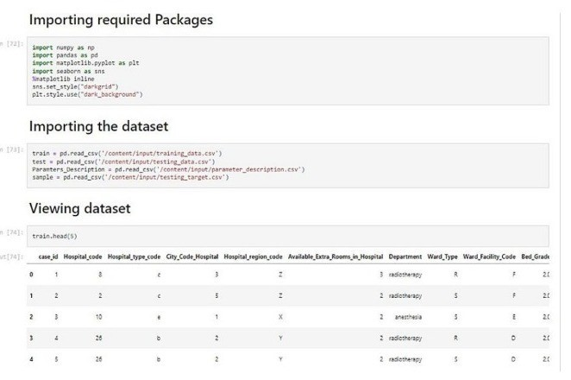

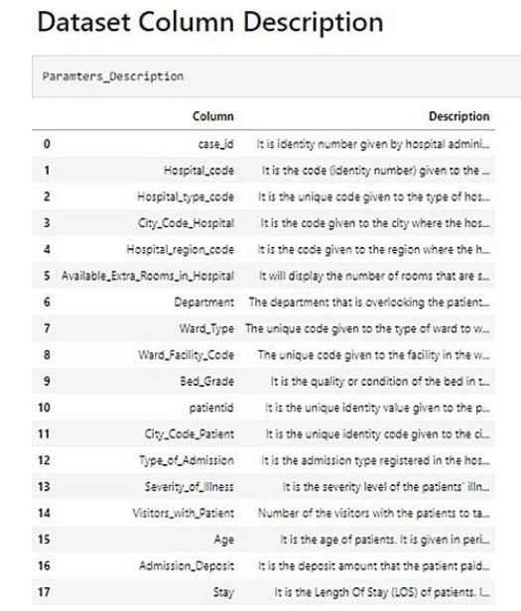

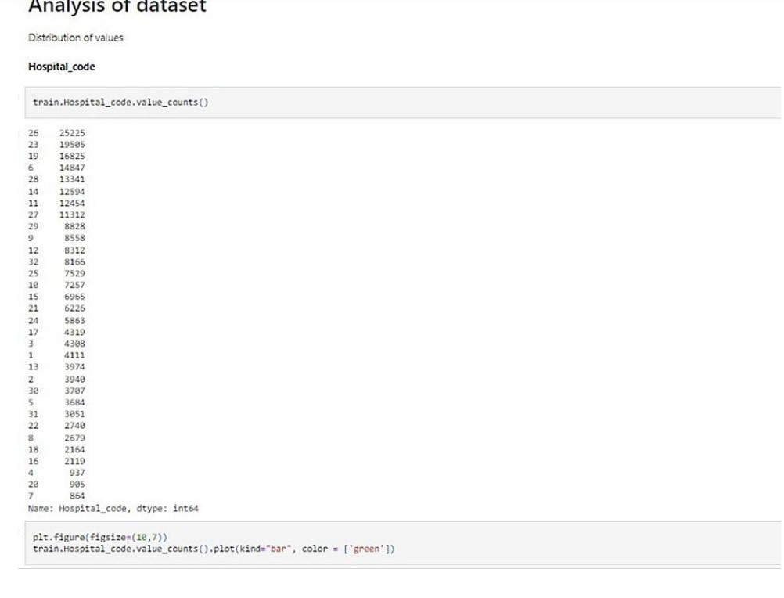

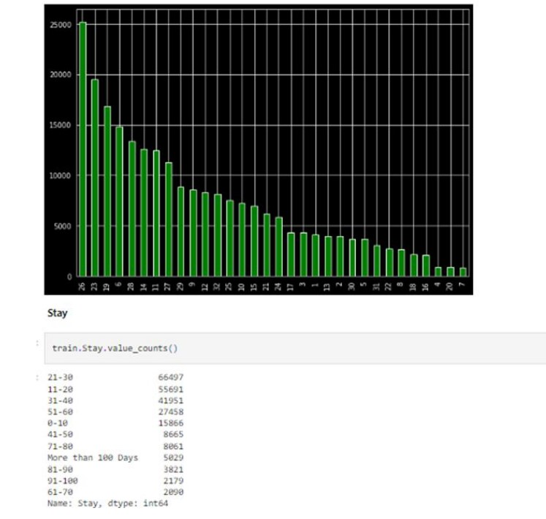

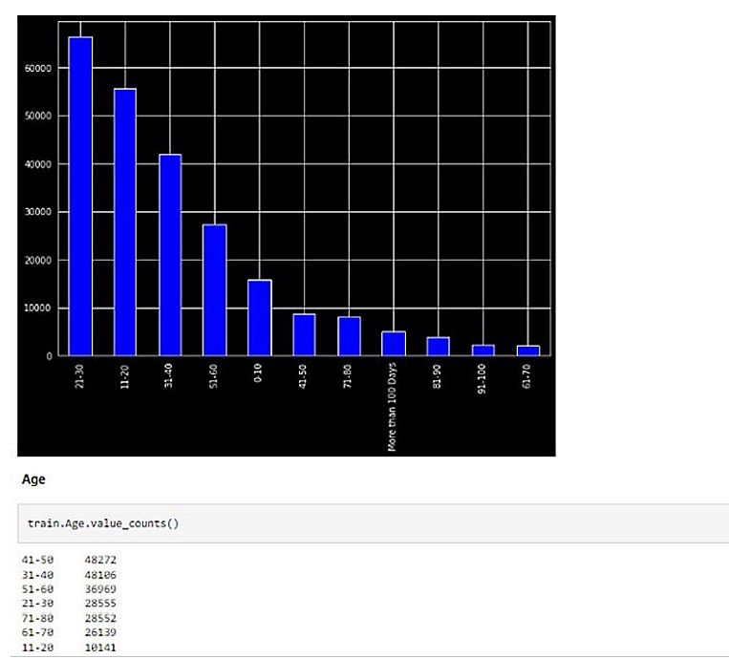

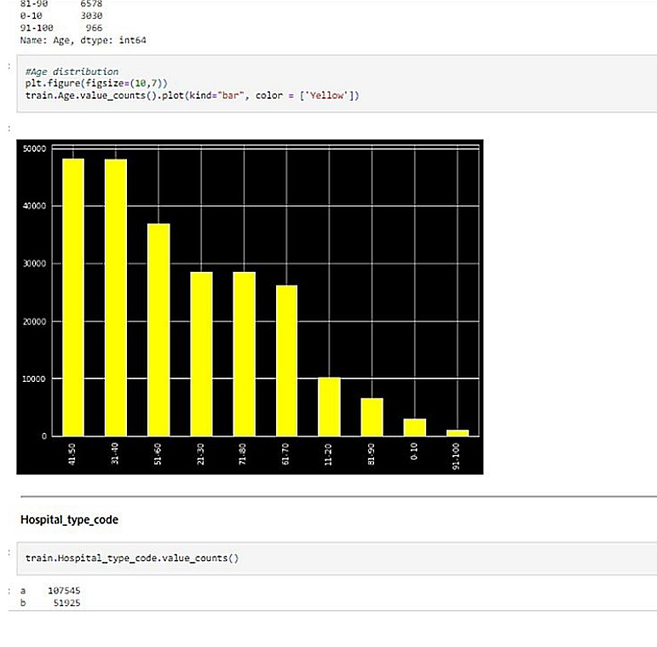

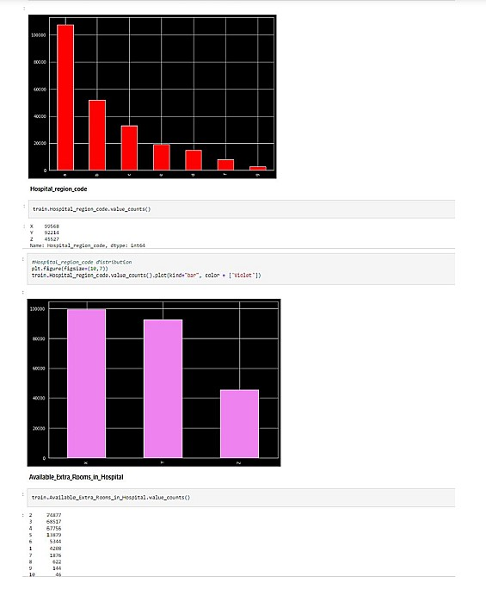

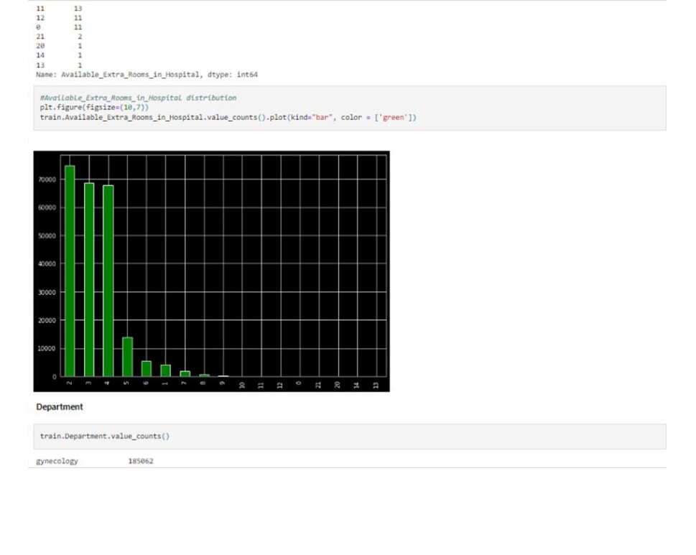

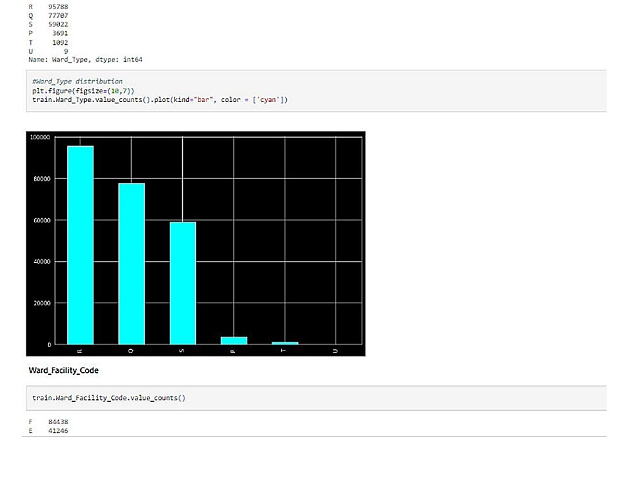

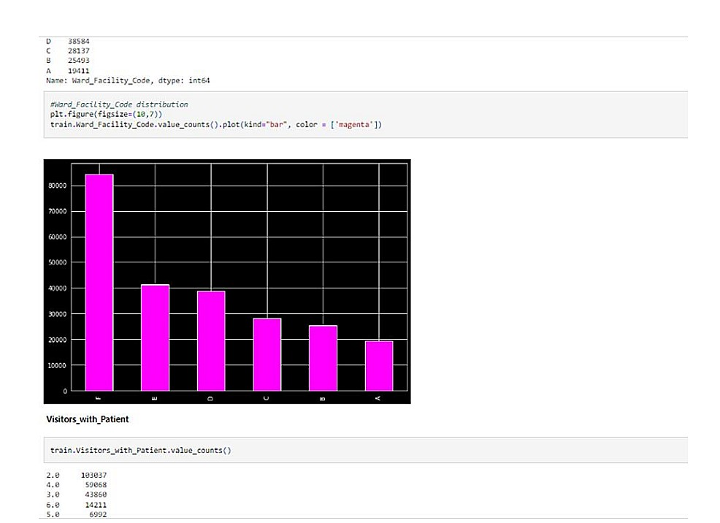

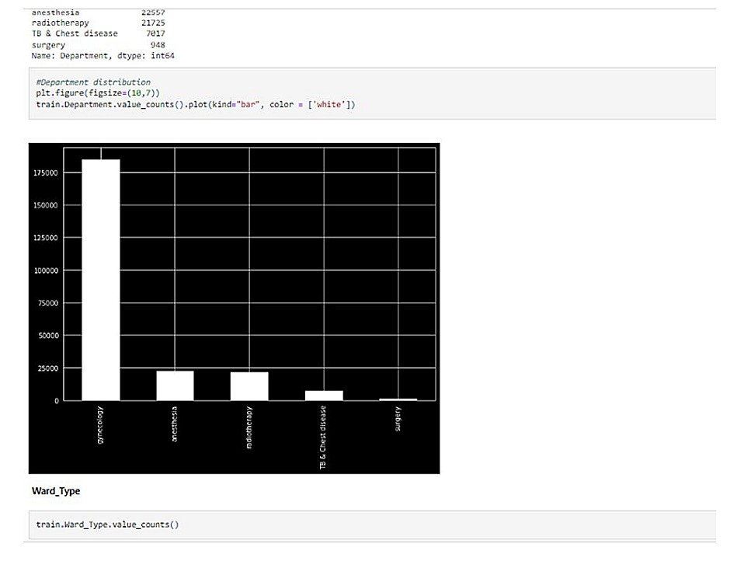

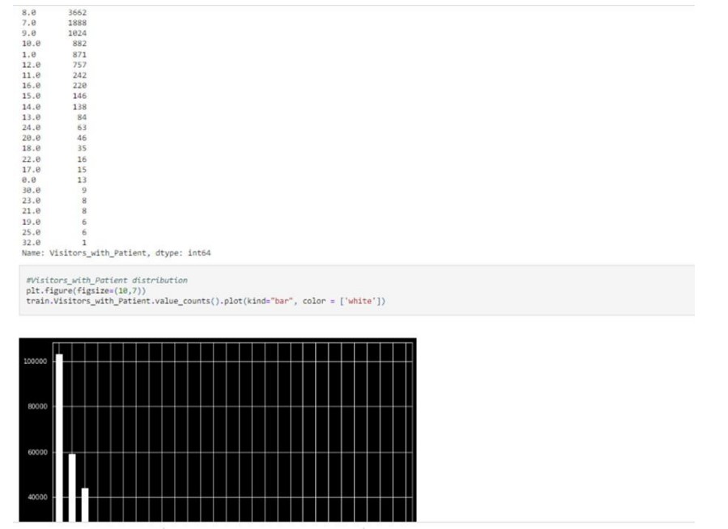

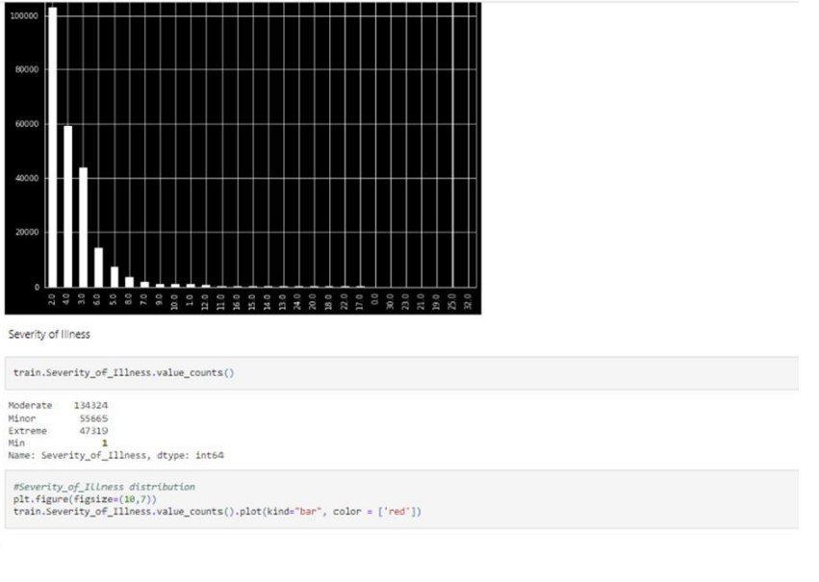

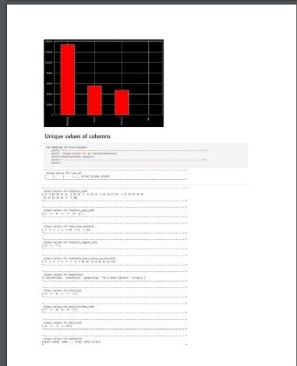

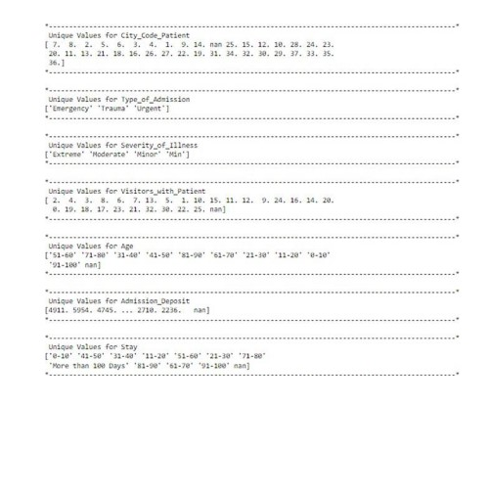

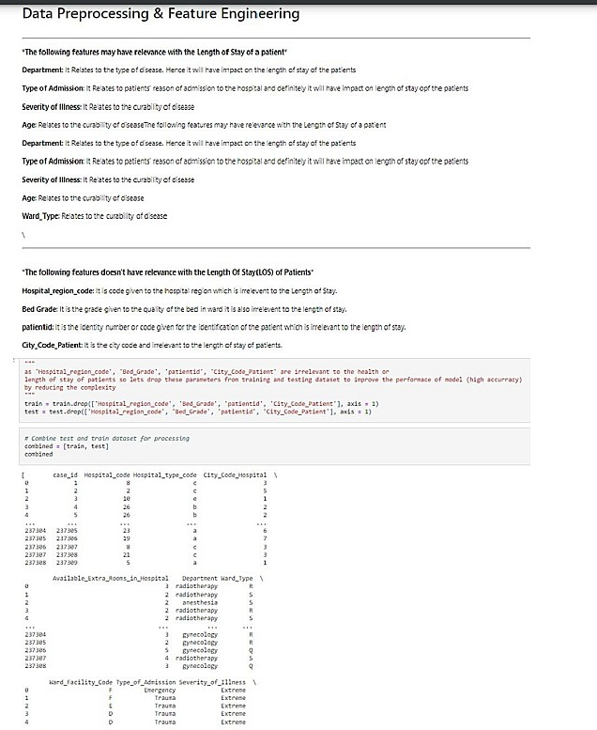

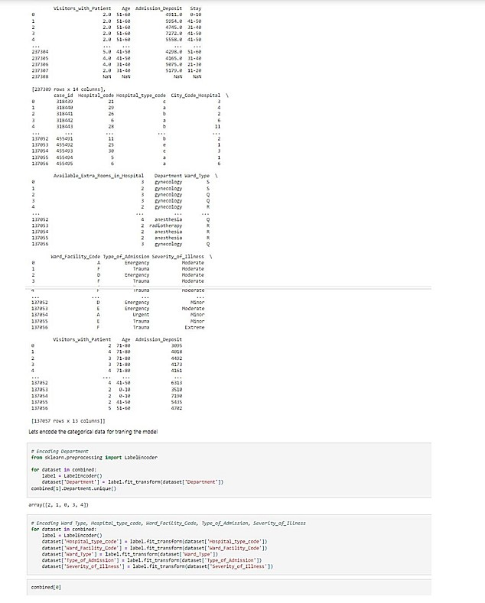

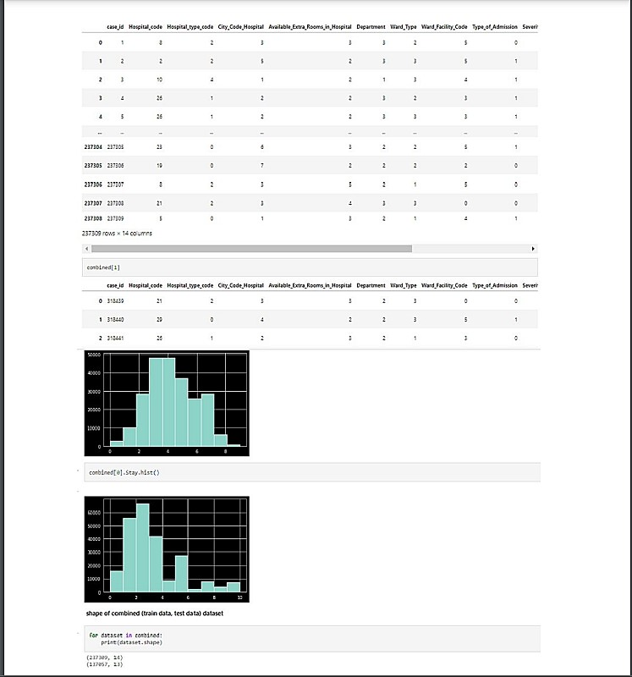

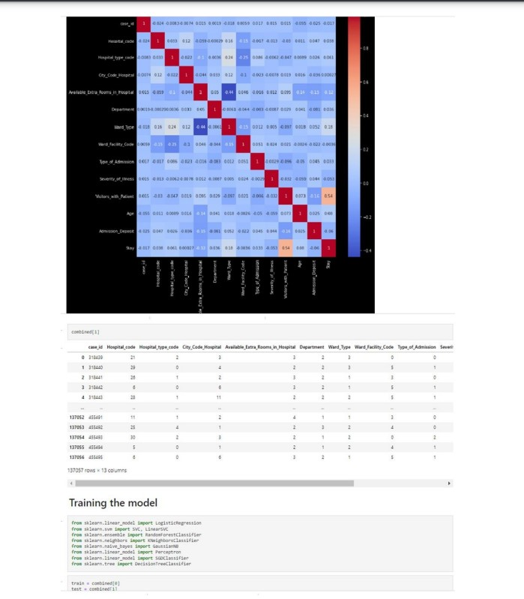

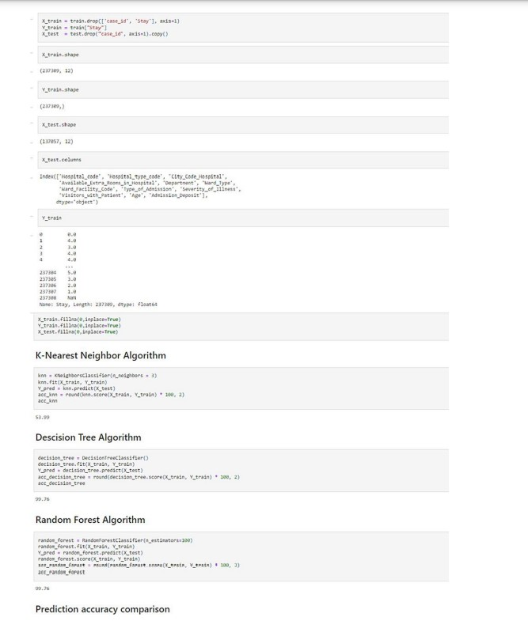

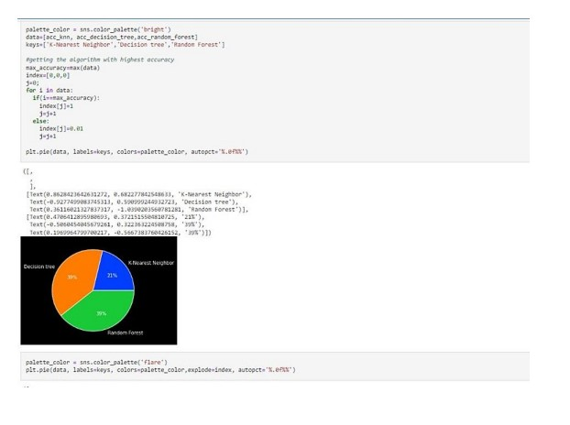

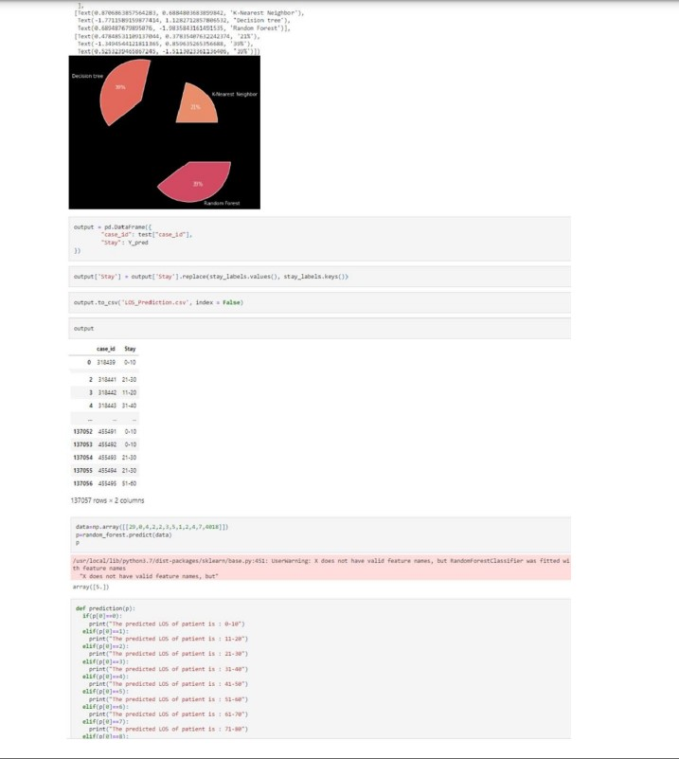

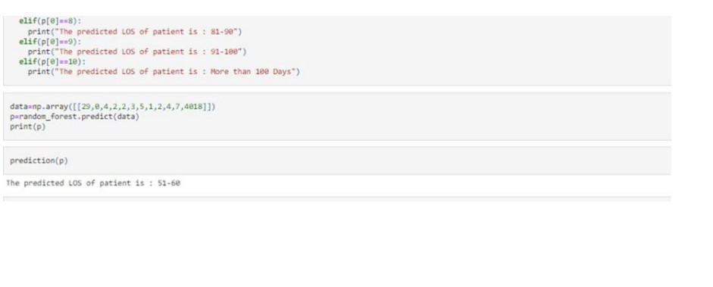

**GIT HUB LINK :**[**https://github.com/IBM-EPBL/IBM-Project-27907-1660099671**](https://github.com/IBM-EPBL/IBM-Project-27907-1660099671)

**PROJECT DEMO LINK :** [**https://drive.google.com/drive/folders/1a4aKYk12-**](https://drive.google.com/drive/folders/1a4aKYk12-5zV6ua8gfF2LJU7D1OjltQ_)

[**5zV6ua8gfF2LJU7D1OjltQ_**](https://drive.google.com/drive/folders/1a4aKYk12-5zV6ua8gfF2LJU7D1OjltQ_)